**Determinant of a Matrix**

* The determinant of a matrix is a **special number** that can be calculated from a square matrix.
* A matrix is an array of numbers:

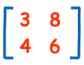  
A Matrix  
(This one has 2 Rows and 2 Columns)

* The determinant of that matrix is (calculations are explained later):

3×6 − 8×4 = 18 − 32 = **−14**

**What is it for?**

* The determinant helps us find the inverse of matrix, tells us things about the matrix that are useful in systems of linear equations, calculus and more.

**Symbol**

* The **symbol** for determinant is two vertical lines either side.
* Example:

**|A|** means the determinant of the matrix **A**

(Exactly the same symbol as absolute value.)

**Calculating the Determinant**

* First of all the matrix must be **square** (i.e. have the same number of rows as columns). Then it is just basic arithmetic. Here is how:

**For a 2×2 Matrix**

* For a 2×2 matrix (2 rows and 2 columns):

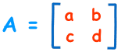

* The determinant is:

|A| = ad − bc  
*"The determinant of A equals a times d minus b times c"*

|  |  |  |
| --- | --- | --- |
| It is easy to remember when you think of a cross:   * Blue is positive (+ad), * Red is negative (−bc) |  | A Matrix |

* Example:

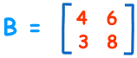

|B|= 4×8 − 6×3

 = 32 − 18

 = 14

**For a 3×3 Matrix**

* For a 3×3 matrix (3 rows and 3 columns):

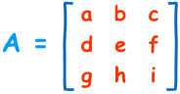

* The determinant is:

|A| = a(ei − fh) − b(di − fg) + c(dh − eg)  
*"The determinant of A equals ... etc"*

* It may look complicated, but**there is a pattern**:

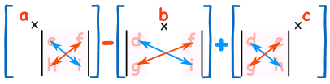

* To work out the determinant of a **3×3** matrix:
* Multiply **a** by the **determinant of the 2×2 matrix** that is**not in a**'s row or column.
* Likewise for **b**, and for **c**
* Sum them up, but remember the minus in front of the **b**
* As a formula *(remember the vertical bars* ||*mean "determinant of")*:

A Matrix  
*"The determinant of A equals a times the determinant of ... etc"*

* Example:

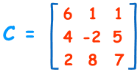

**|C|**= 6×(−2×7 − 5×8) − 1×(4×7 − 5×2) + 1×(4×8 − (−2×2))

 = 6×(−54) − 1×(18) + 1×(36)

 = **−306**

**Not The Only Way**

* This method of calculation is called the "Laplace expansion" and I like it because the pattern is easy to remember. But there are other methods (just so you know).

**Summary**

* For a 2×2 matrix the determinant is**ad - bc**
* For a 3×3 matrix multiply **a** by the **determinant of the 2×2 matrix** that is**not** in **a**'s row or column, likewise for **b** and **c**, but remember that **b** has a negative sign!
* The pattern continues for larger matrices: multiply **a** by the **determinant of the matrix** that is**not** in **a**'s row or column, continue like this across the whole row, but remember the + − + − pattern.